SRS For Event Coordination Engine
Software Requirements Specification (SRS)
1. Introduction
1.1 Purpose
The purpose of this document is to define the requirements for the Event Coordination Engine. This system will facilitate event management by allowing users to propose and register for events and allowing admins to manage events and attendees.
1.2 Scope
The Event Coordination Engine will be a web application with a FastAPI backend and a React frontend. The system will support two user roles: admin and user, each with distinct privileges and functionalities.
1.3 Definitions, Acronyms, and Abbreviations
- ECE: Event Coordination Engine
- API: Application Programming Interface
- RBAC: Role-Based Access Control
2. Overall Description
2.1 Product Perspective
The ECE will be an independent system accessible via web browsers. It will consist of a backend server built with FastAPI and a responsive frontend client built with React. The system will utilize a relational database to store data about users, events, and attendance, etc.
2.2 Product Functions
- User Authentication
- Role-Based Access Control
- Event Proposal Submission and Management
- Event Registration and Attendance Management
- Event Details Viewing
2.3 User Classes
- Admin:
Users with full control over the system, capable of managing events and attendees.
- User:
Regular users who can propose new events, register for events, and view event details.

Characteristics:
a. Admin Role:
- Create and manage events: Admins can add new events, update event details, and delete events.
- Approve or reject event proposals: Admins can review event proposals submitted by users and decide whether to approve or reject them.
- Manage attendees: Admins can view the list of attendees for each event, update their status, and manage the overall attendance list.
b. User Role:
- Propose new events: Users can submit proposals for new events, including all necessary details for admin review.
- Register for events: Users can browse available events and register to attend them.
- View event details: Users can view detailed information about each event, including date, time, location, description, and list of attendees.
2.4 Operating Environment
The system will be a web application, accessible via modern web browsers. The backend will run on a server capable of handling FastAPI applications, and the frontend will be hosted on a suitable web server.
3. Specific Requirements
3.1 Functional Requirements
3.1.1 User Authentication
- The system must support user registration and login.
- The system must enforce strong password policies.
3.1.2 Role-Based Access Control
- The system must distinguish between admin and user roles.
- Admins must have access to all functionalities.
- Users must have restricted access based on their role.
3.1.3 Event Proposal Submission
- Users must be able to submit new event proposals.
- Event proposals must include title, description, date, time, location, and organizer details.
3.1.4 Event Approval and Management
- Admins must be able to view, approve, or reject event proposals.
- Admins must be able to create new events, update event details, and delete events.
3.1.5 Event Registration and Attendance Management
- Users must be able to register for events.
- Admins must be able to view and manage the list of attendees for each event.
3.1.6 Event Details Viewing
- Users must be able to view detailed information about each event.
- Event details must include title, description, date, time, location, and list of attendees.
3.2 Non-Functional Requirements
3.2.1 Performance Requirements
- The system must handle concurrent access by multiple users without significant performance degradation.
- The system must provide a response time of less than 2 seconds for all user actions.
3.2.2 Security Requirements
- The system must implement role-based access control to restrict access to functionalities.
3.2.3 Usability Requirements
- The system must provide a user-friendly interface.
- The system must be accessible via modern web browsers and mobile phones.
3.2.4 Reliability Requirements
- The system must ensure data consistency and integrity.
- The system must provide backup and recovery mechanisms.
4. Constraints:
4.1. User Authentication
- Email Validation: Ensure that the email provided during registration is in a valid format.
- Password Strength: Enforce strong passwords (minimum length, combination of letters, numbers, and special characters).
- Unique Email: Ensure that the email used for registration is unique and not already in use.
4.2. Role-Based Access Control
- Role Enforcement: Ensure that only users with the 'admin' role can access admin functionalities.
4.3. Event Proposal Submission
- Title Validation: Ensure that the event title is not empty and does not exceed a specified length (e.g., 100 characters).
- Description Validation: Ensure that the event description is not empty and does not exceed a specified length (e.g., 1000 characters).
- Date and Time Validation: Ensure that the event date and time are valid and not in the past.
- Location Validation: Ensure that the event location is not empty and is within a specified length (e.g., 200 characters).
4.4. Event Approval and Management
- Proposal Existence: Ensure that the event proposal exists before attempting to approve or reject it.
- Event Existence: Ensure that the event exists before attempting to update or delete it.
- Valid Status Transition: Ensure that status transitions for event proposals (e.g., from pending to approved) are valid and logical.
4.5. Event Registration
- Event Capacity: Ensure that the event has not reached its maximum capacity before allowing a new registration.
- Duplicate Registration: Ensure that a user cannot register for the same event more than once.
- Event Existence: Ensure that the event exists and is approved before allowing registration.
4.6. Event Details Viewing
- Event Visibility: Ensure that users can only view details of events that are approved and not canceled.
5. System Architecture
5.1 Frontend
- The frontend will be built using React.
- It will communicate with the backend via RESTful APIs.
5.2 Backend
- The backend will be built using FastAPI.
- It will handle authentication, authorization, and data management.
5.3 Database
- The system will use a relational database (e.g., PostgreSQL) to store data about users, events, and attendance.
6. User Interface
6.1 Admin Dashboard
- A dashboard for managing events and attendees.
- Interfaces for approving/rejecting event proposals and viewing attendee lists.

6.2 User Dashboard
- A dashboard for proposing new events and registering for events.
- Interfaces for viewing event details and their registration status.
7. Glossary
- Event Proposal: A submission by a user suggesting a new event for approval.
- Registration: The process of a user signing up to attend an event.
- Attendee: A user who has registered for an event.
Class Diagram:
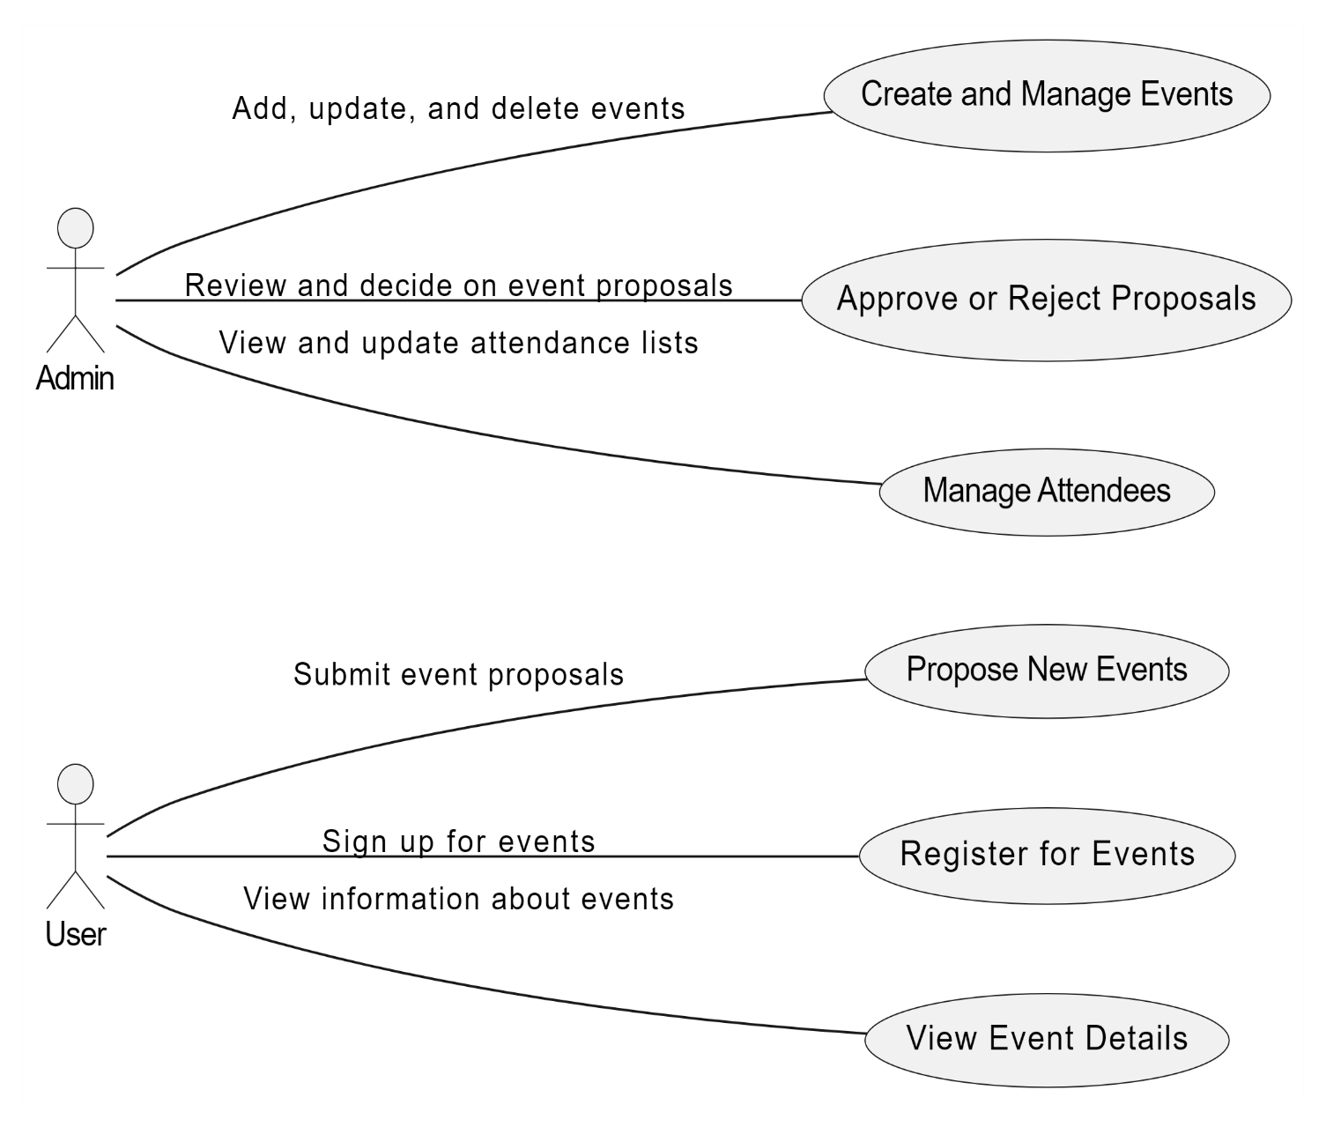

Sequential Diagram:
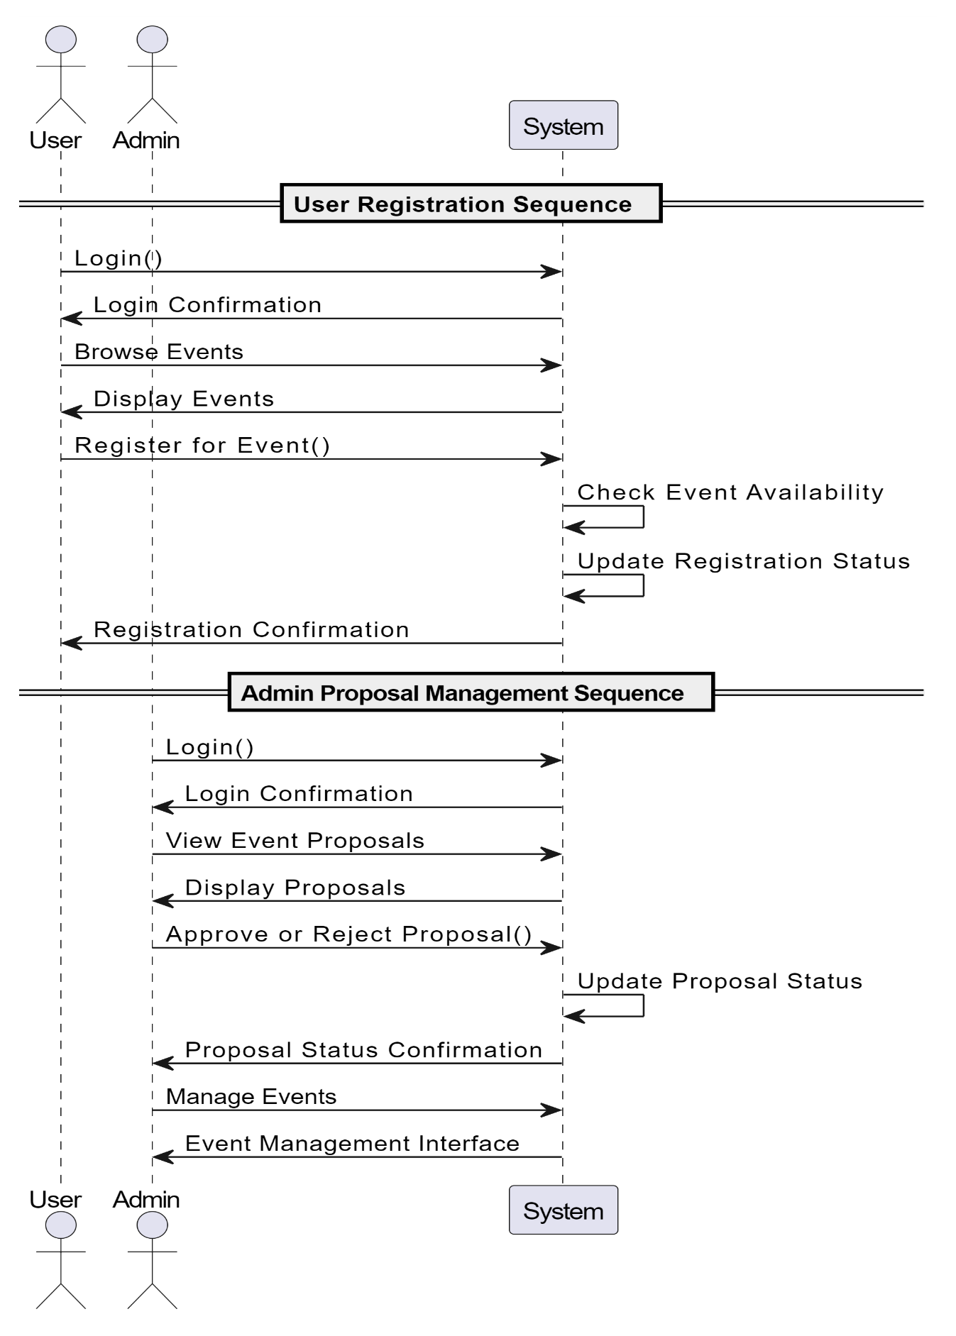

This SRS document outlines the requirements and design constraints for the Event Coordination Engine, providing a clear framework for its development.

